Mini Project Documentation - Kamalishree M

Total data in Australia table - 436

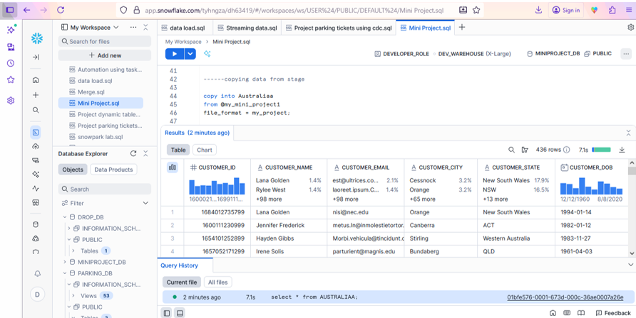

Total data in nsw_t1 table - 78 (new south wales)

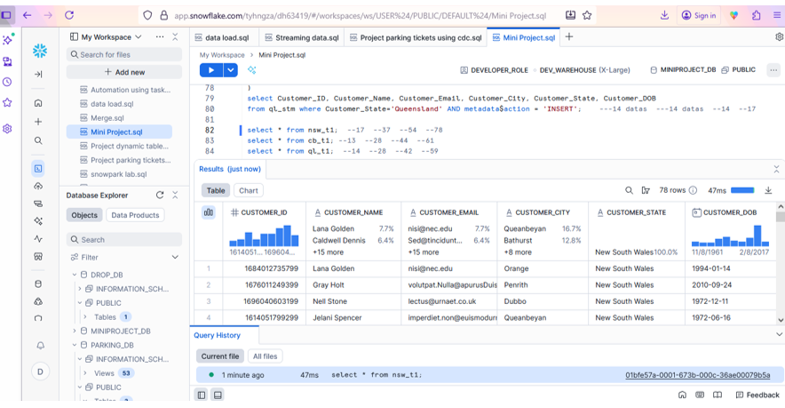

Total data in cb_t1 table - 61 (Victoria)

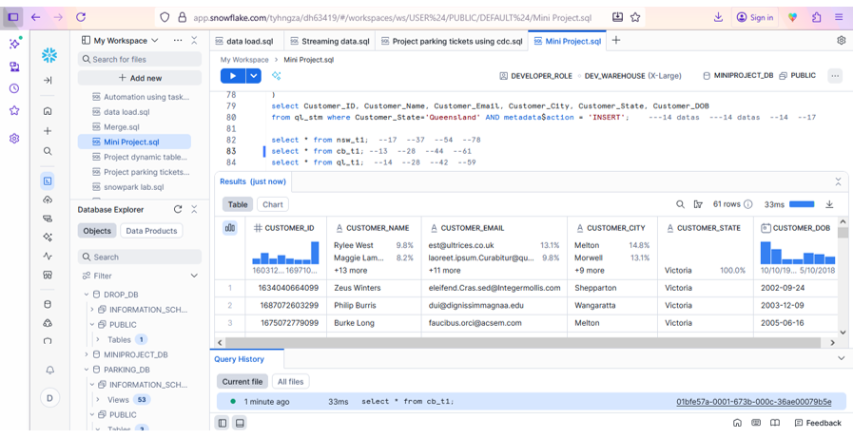

Total data in ql_t1 table 59 (Queensland)

